University Of Engineering and Technology, Lahore
Computer Engineering Department

Course Name: Programming Fundamentals | Course Code: CMPE-112L
Assignment Type:Lab Tasks | Dated: 30-03-2026
Semester: 1st | Session: Spring
Lab/Project/Assignment #: 5 | CLOs to be covered: CLO 2
Lab Title: Functions | Teacher Name: Hafiz Muhammad Mubashar
Lab Evaluation:

CLO1 | Apply appropriate programming techniques to create executable programs to solve well defined problems
 | Level1 | Level2 | Level3 | Level4 | Level5 | Level6
(5)
Total |  |  |  |  |  | /5
Rubrics for Current Lab Evaluation
Scale | Marks | Level | Rubric
Excellent | 5 | L1 | Submitted all lab tasks, BONUS task, have good understanding.
Very Good | 4 | L2 | Submitted the lab tasks but have good understanding
Good | 3 | L3 | Submitted the lab tasks but have weak understanding.
Basic | 2 | L4 | Submitted the lab tasks but have no understanding.
Barely Acceptable | 1 | L5 | Submitted only one lab task.
Not Acceptable | 0 | L6 | Did not attempt
LAB No 5
Lab Goals/Objectives:
To learn Python functions and use them to solve different programming problems.
Equipment Required:
Computer or Laptop, Python 3.x, PyCharm or VS Code.
Theory:
Functions are reusable blocks of code that perform a specific task. They improve program organization and reduce code repetition.
Lab Work:

Task 1: Check whether a number is even or odd.
Result: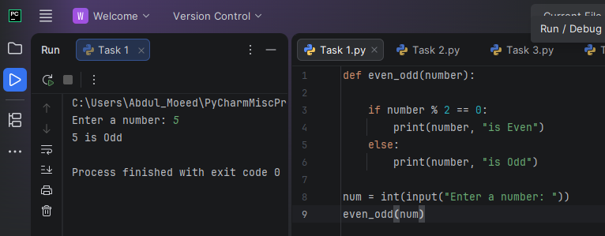

Task 2: Find the largest of three numbers.
Result:
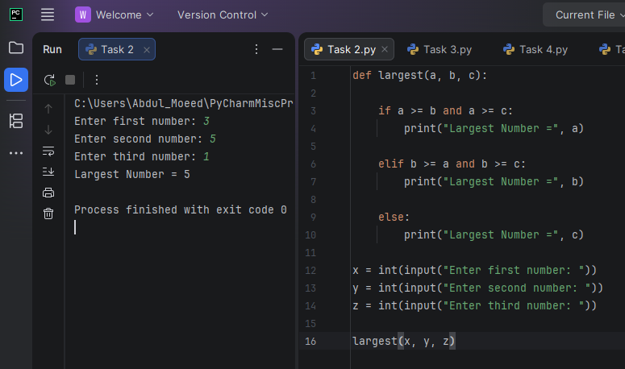

Task 3: Calculate the factorial of a number.
Result:
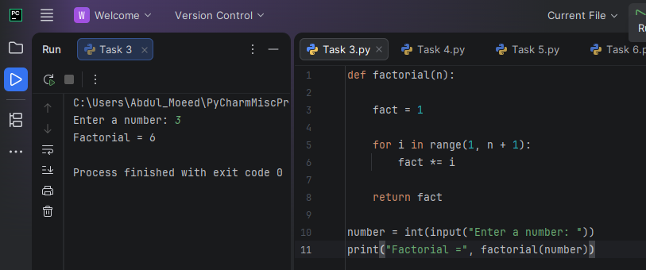

Task 4: Check whether a number is prime.
Result: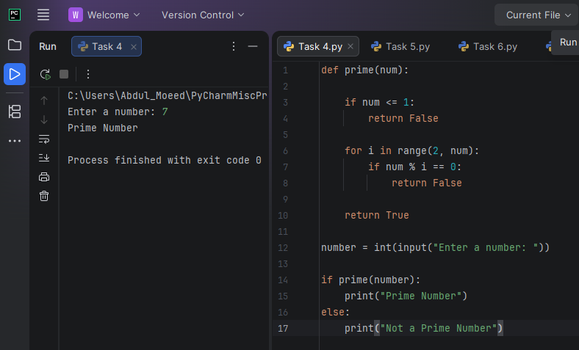

Task 5: Find grade from marks.
Result: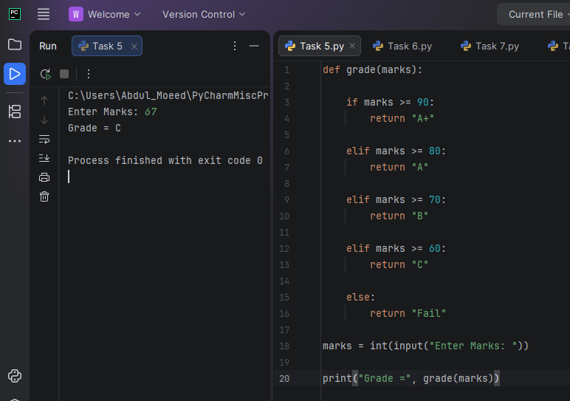

Task 6: Calculate simple interest.
Result:
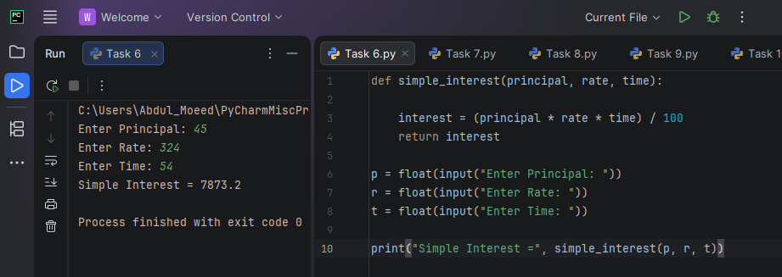

Task 7: Print a multiplication table.
Result: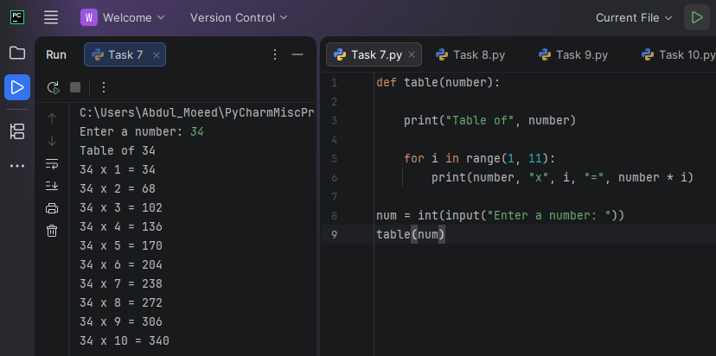

Task 8: Count vowels in a word.
Result:
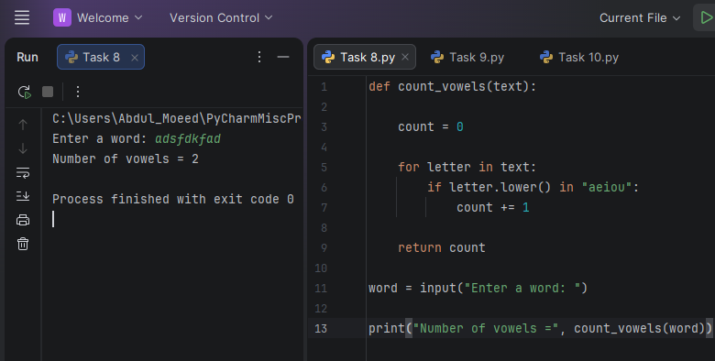

Task 9: Calculate total and average marks.
Result:
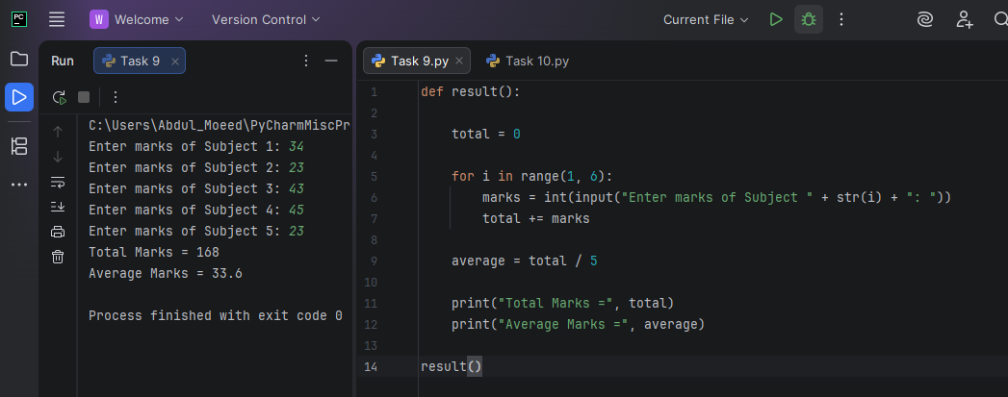

Task 10: Create a login function.
Result:
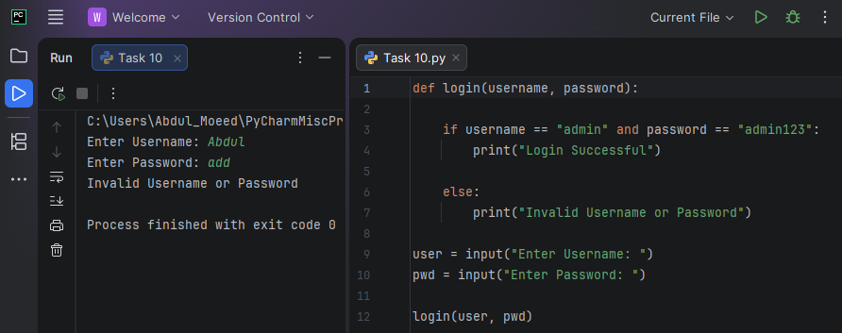

Conclusion:
The lab improved understanding of Python functions and their use in solving different programming tasks.

